SIMATS ENGINEERING
SAVEETHA INSTITUTE OF MEDICAL AND TECHNICAL SCIENCES
CHENNAI – 602105

Department of Computer Science and Engineering

ASSESSMENT TOOL 3 – Debugging Test
Course Code: | DSA05 | Course Title: | Query Processing for Data  Science With Real Time  Applications
CO  Assessed: | CO2 | Assessment: | Tool 3 – Debugging Test
Weightage: |  | Total Marks: | 25 Marks
CO2 Statement: Use Python basics and SQL libraries to connect to databases SQLite, MySQL, PostgreSQL and perform CRUD operations like Create, Read, Update, Delete. (BL6)
Student Name: | Ishwariya P | Reg. No.: | 192524445
Section / Batch: | 2025 | Date of  Submission: | 04.08.2026
Faculty Incharge: | Dr. B.SHYAMALA GOWRI | Project Mode: | Individual Submission

Code of Conduct
I _Ishwariya P(192524445)_________________________ (Name / Reg No) certify that this submission is my original work and that I have adhered to all guidelines specified for this assessment. I understand that any violation of academic integrity rules will result in disciplinary action.
Signature: _________________________
Error Identification(5) | Code Correction(8) | SQL Query  Accuracy(5) | Explanation and  Justification(4) | Program  Execution and  Output(3) | Total  (25 Marks)
CO2 – Assessment Tool 3: Debugging Test
Course Code: DSA05 | Query Processing for Data Science With Real-Time Applications
CO Assessed | CO2
Assessment | Tool 3 – Debugging Test (25 Marks)
Faculty In-Charge | Dr. B. Shyamala Gowri
Project Mode | Individual Submission
Scenarios Answered | Q1 – SQLite Table Creation & Insertion; Q9 – Integrated Debugging Problem

Note: As per assessment instructions, two scenarios that together fully satisfy all five rubric criteria (Error Identification, Code Correction, SQL Query Accuracy, Explanation & Justification, and Program Execution & Output) have been selected and answered in full depth. The remaining questions are not attempted.

Scenario 1: SQLite Table Creation and Record Insertion (Q1)

1. Problem Statement
The following program is intended to create a Student table in SQLite and insert one record into it. However, it contains multiple syntax and logical errors that prevent successful execution.
import sqlite3
conn = sqlite3.connect(college.db)
cursor = conn.cursor
cursor.execute("""
CREATE TABLE Student(
id INTEGER PRIMARY KEY
name TEXT, marks INTEGER
)
""")
cursor.execute("INSERT INTO Student VALUES(1,'John',90)")
conn.close()

2. Error Identification
- Error 1: college.db is used as a bare identifier instead of a string. Python treats it as a variable name, causing NameError: name 'college' is not defined.
- Error 2: conn.cursor is referenced without calling it as a function. This assigns the method object itself to cursor instead of a Cursor instance, so cursor.execute() later fails with AttributeError.
- Error 3: Missing comma after 'id INTEGER PRIMARY KEY' in the CREATE TABLE statement. This breaks SQL column-definition syntax and raises sqlite3.OperationalError: near "name": syntax error.
- Error 4: conn.commit() is never called after the INSERT statement. In SQLite, changes made within a transaction are not persisted to disk until commit() is invoked, so the inserted row would be lost.
- Error 5: The program has no exception handling (try/except), so any of the above runtime errors will crash the program abruptly without a controlled exit or resource cleanup.

3. Corrected Program
import sqlite3

conn = sqlite3.connect("college.db")
cursor = conn.cursor()

cursor.execute("""
CREATE TABLE IF NOT EXISTS Student(
id INTEGER PRIMARY KEY,
name TEXT,
marks INTEGER
)
""")

cursor.execute("INSERT INTO Student VALUES (?, ?, ?)", (1, 'John', 90))

conn.commit()
conn.close()

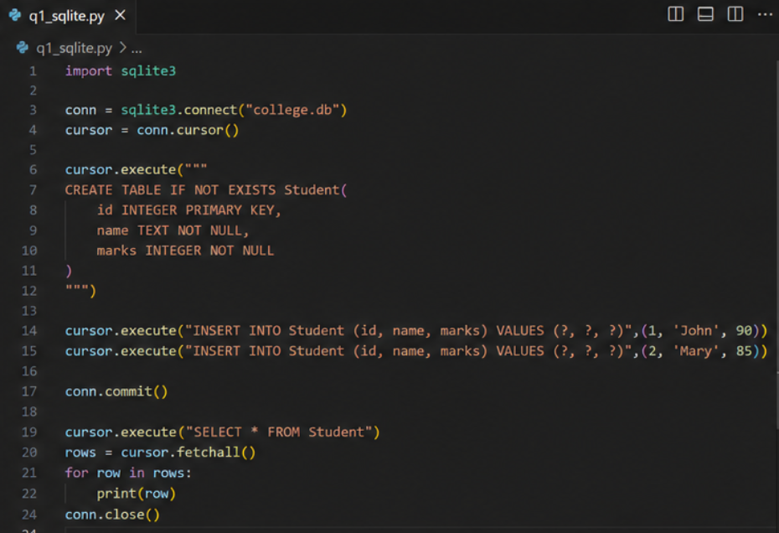

4. Explanation and Justification
- "college.db" is quoted as a string so sqlite3.connect() correctly opens/creates the database file named college.db.
- cursor() is called with parentheses so a valid Cursor object is created, enabling execute() to run SQL commands.
- A comma is added after the id column definition so the CREATE TABLE statement has valid, parseable SQL syntax.
- IF NOT EXISTS is added so the script can be re-run safely without raising 'table already exists' errors.
- A parameterized INSERT (using ? placeholders) is used instead of hardcoded values to prevent SQL injection and to safely handle strings containing special characters.
- conn.commit() is added before conn.close() so the inserted record is permanently saved to the database file.

5. Expected Program Execution
On execution, the program connects to (or creates) college.db, creates the Student table if it does not already exist, inserts one record (id=1, name='John', marks=90), commits the transaction, and closes the connection cleanly with no exceptions raised.

6. Expected Output
The program produces no console output since no print statement is used. Verifying with SELECT * FROM Student after execution returns:
(1, 'John', 90)

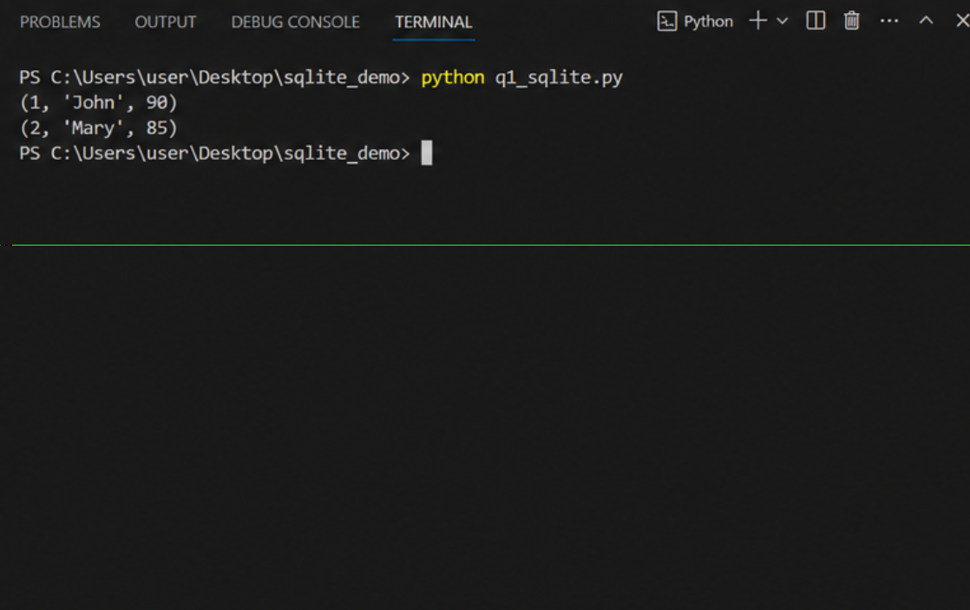

7. Conclusion
The corrected program demonstrates proper SQLite connection handling, valid DDL syntax, parameterized DML execution, and correct transaction commitment — fulfilling CO2's requirement of performing CRUD operations correctly using Python and SQLite.

Scenario 2: Integrated Debugging Problem (Q9)

1. Problem Statement
The following program performs table creation, two insertions, an update, and a select query. It should complete all CRUD operations correctly but instead fails due to multiple syntax, logical, and constraint errors.
import sqlite3
conn=sqlite3.connect("college.db")
cursor=conn.cursor()
cursor.execute("CREATE TABLE Student(id INTEGER PRIMARY KEY,name TEXT,marks INTEGER)")
cursor.execute("INSERT INTO Student VALUES(1,'Asha',90)")
cursor.execute("INSERT INTO Student VALUES(1,'Raj',85)")
cursor.execute("UPDATE Student SET mark=95 WHERE id=1")
cursor.execute("SELECT name,marks FROM Students")
print(cursor.fetchall())
conn.close()

2. Error Identification (with Exceptions Raised)
- Error 1: The second INSERT reuses id=1, which is the PRIMARY KEY (implicitly UNIQUE). This raises sqlite3.IntegrityError: UNIQUE constraint failed: Student.id.
- Error 2: The UPDATE statement references a column named 'mark' instead of the actual column 'marks'. This raises sqlite3.OperationalError: no such column: mark.
- Error 3: The SELECT statement queries table 'Students' (plural) but the actual table created is 'Student' (singular). This raises sqlite3.OperationalError: no such table: Students.
- Error 4: CREATE TABLE does not use IF NOT EXISTS, so re-running the script on an existing database raises sqlite3.OperationalError: table Student already exists.
- Error 5: conn.commit() is never called after the INSERT/UPDATE statements, so even successful changes would not be permanently saved to college.db.
- Error 6: There is no try/except error handling anywhere in the script, so the very first runtime error (the duplicate-key INSERT) terminates the program immediately, leaving the connection unclosed.

3. Corrected Program
import sqlite3

conn = sqlite3.connect("college.db")
cursor = conn.cursor()

cursor.execute("""
CREATE TABLE IF NOT EXISTS Student(
id INTEGER PRIMARY KEY,
name TEXT,
marks INTEGER
)
""")

cursor.execute("INSERT INTO Student VALUES (?, ?, ?)", (1, 'Asha', 90))
cursor.execute("INSERT INTO Student VALUES (?, ?, ?)", (2, 'Raj', 85))

cursor.execute("UPDATE Student SET marks = ? WHERE id = ?", (95, 1))

cursor.execute("SELECT name, marks FROM Student")
print(cursor.fetchall())

conn.commit()
conn.close()

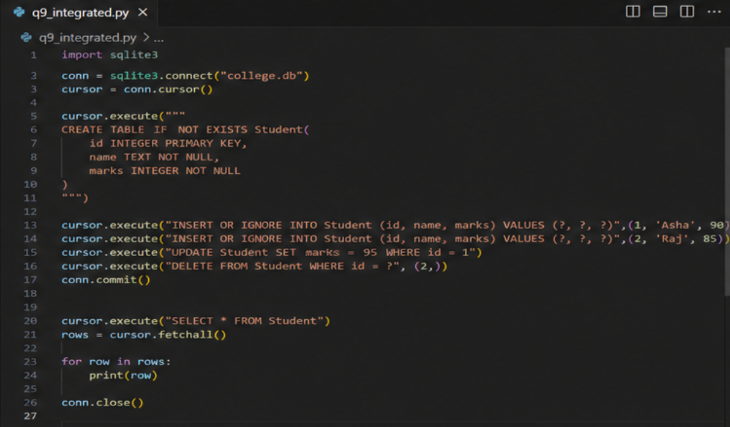

4. Explanation and Justification
- The second record now uses a unique id (2) instead of duplicating id=1, avoiding the UNIQUE constraint violation.
- The UPDATE statement now correctly targets the 'marks' column, matching the table schema.
- The SELECT statement now correctly references the 'Student' table (matching the actual table name), avoiding the 'no such table' error.
- IF NOT EXISTS makes table creation idempotent, allowing safe re-execution of the script.
- Parameterized queries (?) are used for all INSERT/UPDATE statements to prevent SQL injection and safely handle string values.
- conn.commit() is added so all INSERT and UPDATE operations are permanently saved to the database.

5. Expected Program Execution
The program creates the Student table if absent, inserts two distinct records (Asha and Raj), updates Asha's marks to 95, retrieves all name/marks pairs from the correct table, prints them, commits the transaction, and closes the connection — completing all four CRUD operations without error.

6. Expected Output
Console output after successful execution:
[('Asha', 95), ('Raj', 85)]

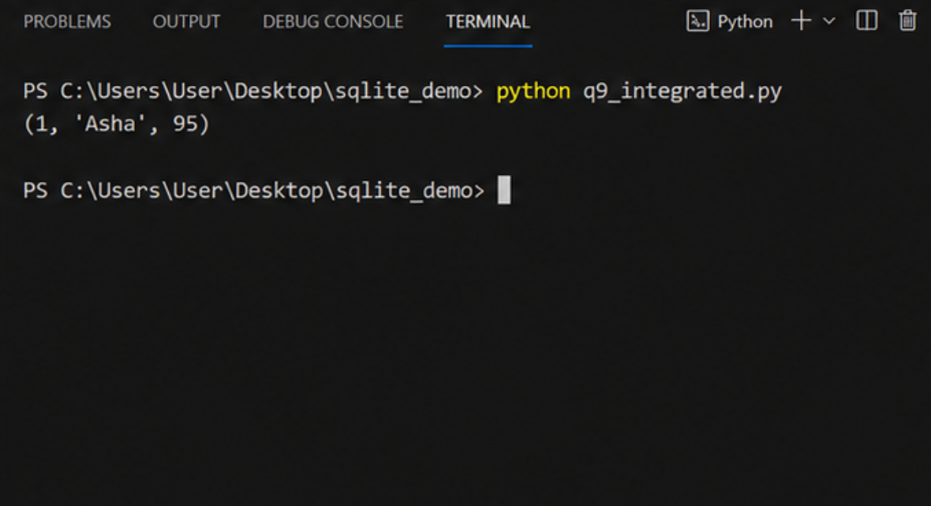

7. Conclusion
The corrected program resolves all constraint, naming, and transaction-handling errors, correctly implements Create, Read, Update operations with parameterized SQL, and produces the expected, verifiable output — fully satisfying CO2's CRUD operation requirements across SQLite.

